Task 4: Scale containerized workloads in the Azure Kubernetes service cluster

1. From the **Cloud Shell** pane, and run the following to scale the deployment by increasing of the number of pods to 2:

C:\Users\Daniel\Desktop\Az kubernetes\1.png

1. From the **Cloud Shell** pane, run the following to verify the outcome of scaling the deployment:

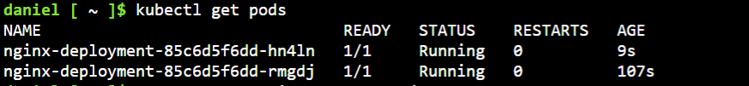

1. From the **Cloud Shell** pane, run the following to scale out the cluster by increasing the number of nodes to 2:

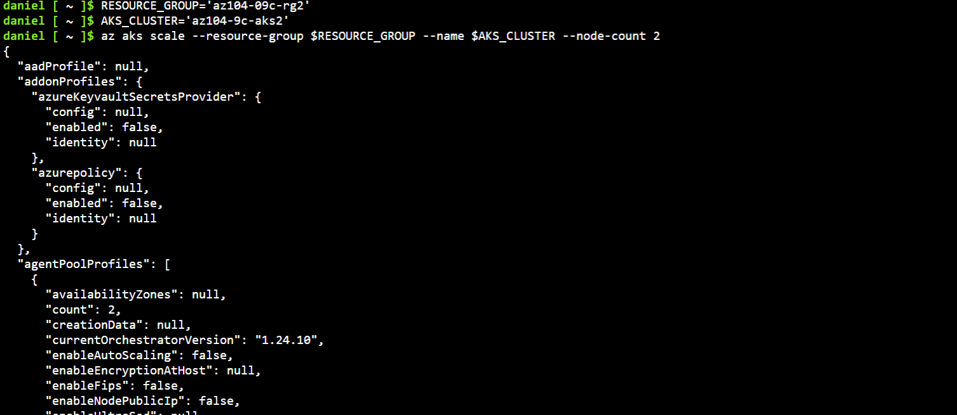

1. From the **Cloud Shell** pane, run the following to verify the outcome of scaling the cluster:

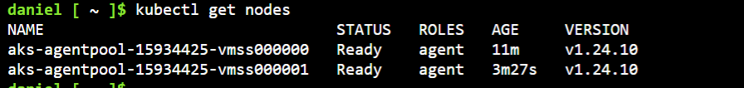

1. From the **Cloud Shell** pane, run the following to scale the deployment:

C:\Users\Daniel\Desktop\Az kubernetes\5.png

1. From the **Cloud Shell** pane, run the following to verify the outcome of scaling the deployment:

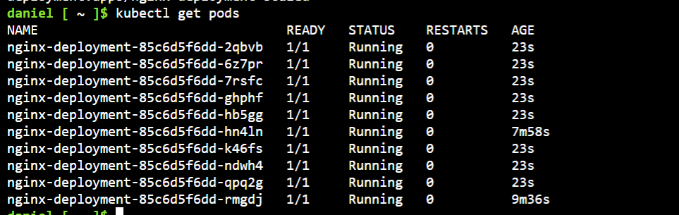

1. From the **Cloud Shell** pane, run the following to review the pods distribution across cluster nodes:

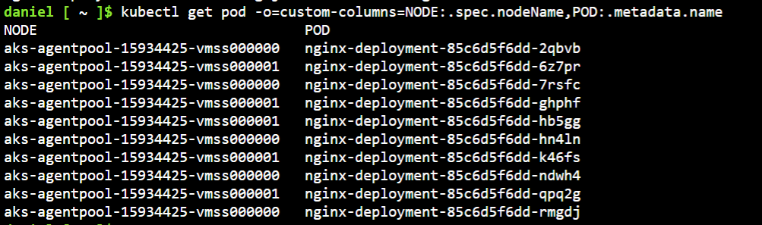

1. From the **Cloud Shell** pane, run the following to delete the deployment:

C:\Users\Daniel\Desktop\Az kubernetes\8.png